DOCUMENTATION OF RESULTS OF PHASE -2 ALONG WITH RETENTION STRATEGIES INDICATOR MAPPINGS

GO THROUGH ALL THE STEPS FROM 1 TO 6 BELOW:

Step 1:

Checking the total count of 9box category csv so that when merging both the csv’s side by side no issues related to the count of reviews shud occur – (1)  
A)n=4200

Step 2:

Gnerate the same (n) review from the emp to manager/company in a csv –(2)

Step 3:

In (2) csv  
->witht the given indicators create some ratio of real data reviews

A)1500 positive and 1500 negative reviews generate with the given indicators from oracle resource

->remaining reviews should be added as data augmentation for better model generalization

A)with added indicators (4-5 indicators) new csv generated such that 600 review samples in each class

->Now total 600+1500 = 2100 positive and 2100 negative =>4200 samples < == > matched with the manager to employee feedback count also i.e.,n

Step 4:

With this (2) csv train the model

From 90-10 to 50-50 and save 90-10 model

A)Results of the model performance is given below

**90-10**

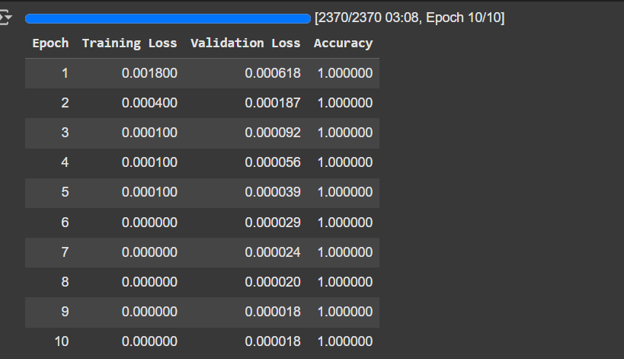

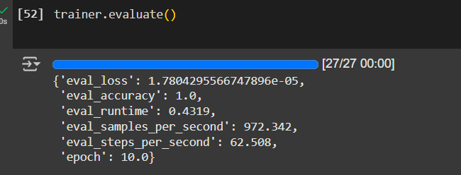

**80-20**

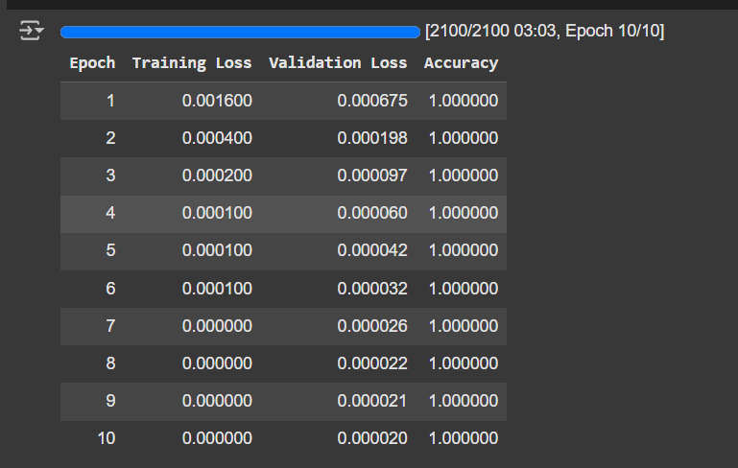

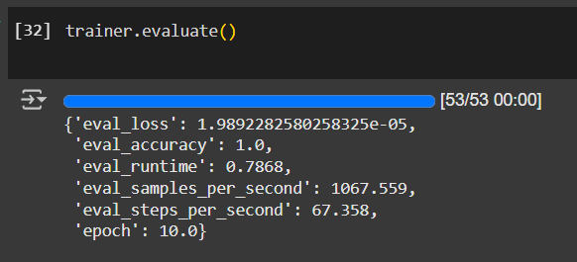

**70-30**

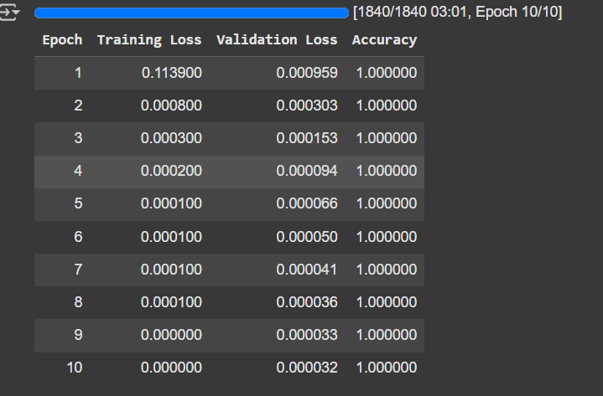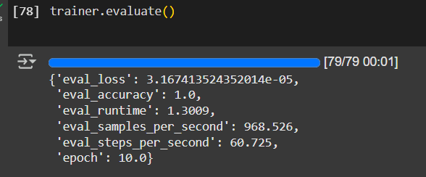

**60-40**

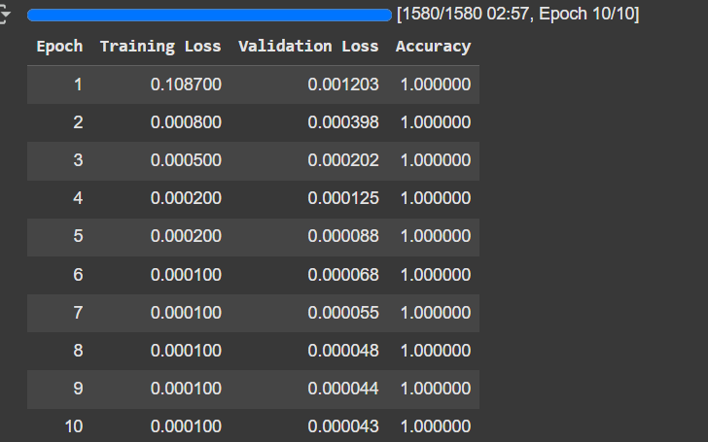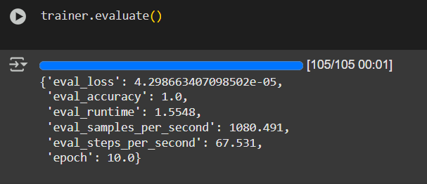

**50-50**

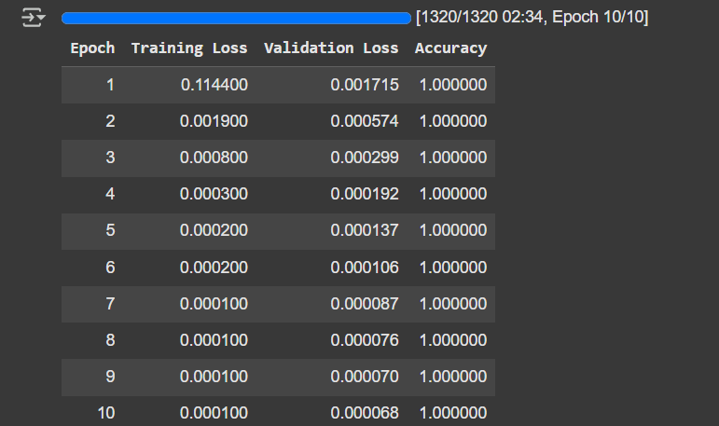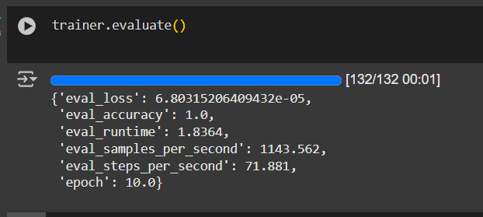

Step 5:

After training the model, next mapping results given below

**Indicators of Leaving (Attrition)**

1. **Compensation Dissatisfaction**  
   *Words to match (Old + New):*  
   "underpaid", "salary not competitive", "pay below market", "poor salary package", "unfair compensation", "lack of incentives", "not paid well"  
   *Mapped to:* **Compensation Dissatisfaction**
2. **Lack of Career Growth**  
   *Words to match (Old + New):*  
   "no growth opportunities", "dead-end job", "no promotions", "skills not used", "career is stagnant", "no learning path", "no professional development", "stuck in same role", "no internal mobility"  
   *Mapped to:* **Lack of Career Growth**
3. **Poor Management**  
   *Words to match (Old + New):*  
   "micromanaged", "poor leadership", "no feedback", "manager doesn’t listen", "bad supervision", "lack of guidance", "unsupportive boss", "authoritarian manager", "management is clueless"  
   *Mapped to:* **Poor Management**
4. **Lack of Work-Life Balance**  
   *Words to match (Old + New):*  
   "long hours", "can’t disconnect", "burned out", "no flexibility", "overworking", "always on call", "no personal time", "no time for family", "zero work-life integration"  
   *Mapped to:* **Lack of Work-Life Balance**
5. **Poor Culture or DE&I**  
   *Words to match (Old + New):*  
   "toxic culture", "not inclusive", "favoritism", "unfair treatment", "hostile environment", "cliquish teams", "bias in decision making", "lack of diversity", "unsafe workplace"  
   *Mapped to:* **Poor Culture or DE&I**
6. **Lack of Recognition or Support**  
   *Words to match (Old + New):*  
   "not appreciated", "hard work ignored", "not valued", "feel invisible", "never acknowledged", "no appreciation", "efforts go unnoticed", "unsupported", "ignored by team"  
   *Mapped to:* **Lack of Recognition or Support**
7. **Negative Workplace Changes**  
   *Words to match (Old + New):*  
   "constant changes", "no communication", "layoffs", "don’t explain changes", "sudden restructuring", "unclear policies", "frequent leadership changes", "instability", "lack of transparency"  
   *Mapped to:* **Negative Workplace Changes**
8. **Lack of Benefits / Well-being Support**  
   *Words to match (Old + New):*  
   "no mental health support", "no wellness programs", "stressful environment", "no health perks", "no work perks", "no PTO", "no support for burnout", "well-being ignored"  
   *Mapped to:* **Lack of Benefits / Well-being Support**

**Indicators of Staying (Retention)**

1. **Fair Pay & Benefits**  
   *Words to match (Old + New):*  
   "competitive salary", "good benefits", "great insurance", "bonuses", "market-aligned pay", "well-compensated", "fair salary", "extra perks", "transparent pay policy"  
   *Mapped to:* **Fair Pay & Benefits**
2. **Career Development**  
   *Words to match (Old + New):*  
   "learning opportunities", "upskilling", "growth path", "promotion", "skill-building programs", "continuous development", "clear career ladder", "mentorship plans", "training support"  
   *Mapped to:* **Career Development**
3. **Supportive Managers**  
   *Words to match (Old + New):*  
   "great leadership", "understanding manager", "mentorship", "manager listens", "encouraging boss", "trusted leadership", "open-door policy", "constructive feedback"  
   *Mapped to:* **Supportive Managers**
4. **Work-Life Balance**  
   *Words to match (Old + New):*  
   "flexible hours", "respect personal time", "remote work options", "good flexibility", "healthy work-life separation", "family-friendly schedule", "time autonomy", "reasonable workload"  
   *Mapped to:* **Work-Life Balance**
5. **Positive Culture**  
   *Words to match (Old + New):*  
   "inclusive", "collaborative", "team-oriented", "fun workplace", "supportive peers", "friendly environment", "open culture", "belongingness", "value-driven company"  
   *Mapped to:* **Positive Culture**
6. **Recognition and Feedback**  
   *Words to match (Old + New):*  
   "get acknowledged", "manager appreciates me", "recognized for work", "positive reinforcement", "frequent praise", "spot bonuses", "feedback-rich", "rewarded for effort"  
   *Mapped to:* **Recognition and Feedback**
7. **Well-being Focus**  
   *Words to match (Old + New):*  
   "mental health support", "low stress", "wellness programs", "feel cared for", "health-first culture", "access to therapy", "employee assistance", "balanced environment", "focus on wellness"  
   *Mapped to:* **Well-being Focus**

Step 6:

The combined CSV along with the 90-10 saved model is sent to you in whastapp and mail respectively..